**Credit DAO**

A credit scoring service provider for DeFI

Content

Intoduction 3

1. What is Credit DAO? 3

2. Background 3

3. Why credit DAO? 4

4. Terminology **错误!未定义书签。**

Architecture 5

1. Overview 5

2. Members 5

3. Funding pools 6

4. Profile 7

5. Verification tool: 7

6. C-Token: 7

7. Wallet 7

8. Smart contract: 7

Consensus 7

# Intoduction

## What is Credit DAO?

The Credit DAO is designed to provide a credit scoring service for every anonymous participant. Credit DAO encourages members to provide their own data, jointly develop a set of distributed machine learning models, generate data value, and discuss benefit distribution together. To some extent, Credit DAO is somewhat similar to rating agencies like Moody's. Credit DAO makes profits by selling credit scores to data consumer.

A simple framework diagram is as follows, the following chapters will provide details.

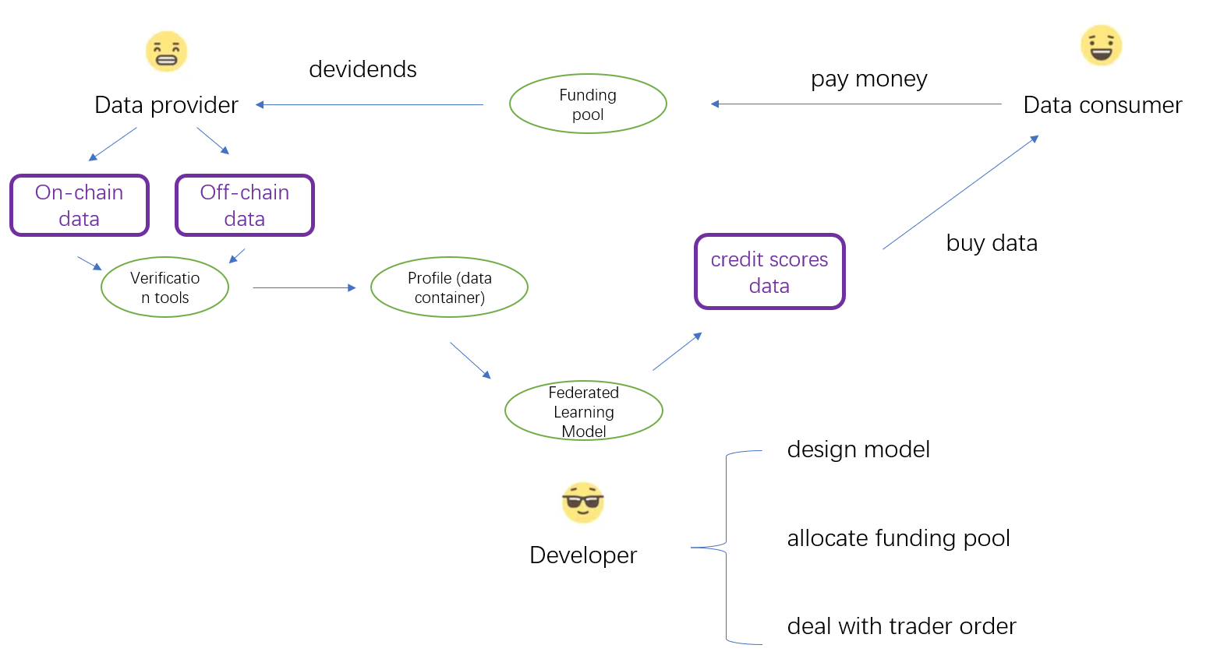

## Background

DeFI requires credit scores. A modern financial system cannot be without credit, otherwise (unfortunately, this is exactly the difficulty DeFI is currently facing), many loans can only be based on collateral requirements (like Compound) or strict limitations (like flash loan). Both of strict collateral requirements and limitations can bring market inefficiency, such as low liquidity utilization (because of collateral requirements), limitations on the use of funds (because of the margin requirements), narrow customer sectors (in fact, only 0.2% of Ethereum wallets have made transactions with a Defi Lender). Therefore, DeFI needs credit lending. And credit lending is inseparable from credit scores.

Besides, technologies such as eID, DID, and Inter-Blockchain are developing rapidly. This makes credit scoring became the trend of the future. More specifically, these technologies will integrate on-chain data and off-chain data. Thus, in the future, the data volume of DeFI will grow rapidly, which provides soil for credit scoring.

## Why credit DAO?

1. Members can mine value in data

Data producers can provide their data in exchange for credit scoring services, such as getting credit scores or ratings. In the future, producers can utilize their credit scores to obtain benefits. For example, when applying for a loan, they can use to the credit score to prove that they have good repayment willingness and repayment ability, so as to get some discounts. We can see that, In the process from raw data to credit scores, new value is created from raw data.

1. Data has high quality

The data sources of Credit DAO include on-chain data and off-chain data. On-chain is authentic and credible because they come from the records in blockchains. As for off-chain data, the adoption of DID, eID can ensure the authenticity and credibility of the data. Besides, these technologies can ensure robustness to Sybil Attack. Therefore, the data has high quality, which ensures the credit scores are reliable at the data source level.

1. Data privacy protection is guaranteed

Data producers can upload private data and enjoy credit score services without worrying about privacy leakage. Because Credit DAO will apply Federated Learning technology to develop machine learning models. Compared with traditional machine learning techniques, when using traditional machine learning techniques, if we want to train models, we have to collect the user's data in a centralized manner, which brings privacy leakage problems. However, Federated Learning it allows users to train a small part of the model on their local device, and then these trained model fragments will be integrated into the final model. In other words, Federated Learning doesn’t require copying or moving user’s data. Thus, avoiding the privacy leakage problem caused by collecting data.

1. Avoid data hegemony

The decentralized organizational form of DAO helps to avoids problems such as data exploitation and data hegemony. In the real world, our data will be taken by a certain platform and used to train advertising recommendation models or scoring models. So, there is information asymmetry between the platform and the user, while leads to problems like discrimination and unfairness. For example, prior to 2008, Moody's rating has bribery and rating manipulation problems. Besides, unfortunately, although technologies such as Web3 can protect the data ownership of individuals, they can not mitigate the data hegemony problem at all. More specifically, users completely lose control over their data after selling data to data consumers. Besides, it is difficult for users to determine whether their data pricing is reasonable, and platforms can easily utilize information asymmetry to implement price exploitation. So, technologies such as Web3 appear to protect data, but in fact only provide a platform for "Faustian transactions." Selling your soul to the devil is a terrible thing. So, we need the Credit DAO. Credit DAO does not encourage data producers to directly sell raw data to data consumers. Instead, we encourage data producers and data consumers to jointly develop and supervise a set of data analysis tools (such as machine learning models), and then data producers sell data analysis results. to data consumers. Compared with the original data, the data consumer and the data producer have reached a higher consensus on the value of the analysis results (because it is generated from jointly developed data analysis tools), and the analysis results are more timeliness, which alleviates the " Faustian transactions " problem.

# Architecture

## Overview

The Credit DAO consists of the following elements:

* member: Participants of the Credit DAO.
* Funding pools: container for storing money.
* profile: A container for storing member data.
* verification tool: used for integrate on-chain data, besides, it can be used for linked to DID and eID and verify offline data.
* C-Token is used for trading data. S-Token is used for voting and enjoy rights.
* wallet: A container for storing member tokens
* smart contract: includes three important types of contracts: 1. Model 2.Funding 3.Trade order

## Members

Three are three types of Members in Credit DAO. Besides, Credit DAO adopt the Delegated Proof of stake (DPoS) consensus.

|  |  |  |
| --- | --- | --- |
| Member Type | Things they can do | Benefits they can get |
| * Data producer | **Provide data** | Get C-token |
| Verify DID/eID | Gain the right to be elected as a developer |
| * Data consumer | Pay **money** and buy credit scores data | Get data |
| Pay **money** for joining the development | Within a certain period, have the right to appoint up to 10% of the developers |
| * Data developer | **Vote** or Initiate **proposals** to make decision for model designing and profit distribution. | Have to right for voting or making proposals. |

## Funding pools

All the money paid by the data consumer will firstly enter into the funding pool. Then the money in the funding pool will be allocated periodically. The distribution is shown as the follows:

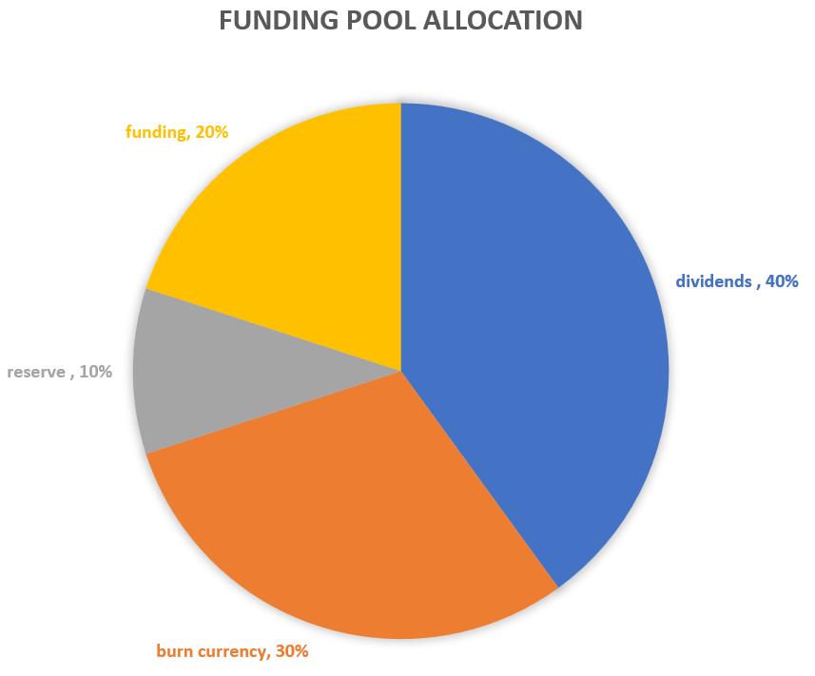

Those who hold C-token can get dividends.

Funding is used for paying for marketing, operation, development.

Burn currency money is used for forcing members to exchange C-token for money.

Reserve is the money prepared for the next operating cycle.

## Profile

Profile is a container for storing member data. Each members has his own profile. The data in the profile is protected by asymmetric encryption technology. Members can choose to show data to others according to their preferences.

## Verification tool:

Verification tools are used for integrate on-chain data, besides, it can be used for linked to DID and eID and verify offline data.

## C-Token:

C-Token is used for voting and enjoy rights. Members can get C-token via providing data and working as developers.

## Wallet

A container for storing member tokens. Each members have his own wallet as his account.

## Smart contract:

There are three types of Smart contract:

1. Model: A series of smart contracts used for designing and maintaining the Federated learning model.

2. Funding: Used for managing the use of the Credit DAO funding pool.

3. Trader order: Used for deciding the price of traders (in other words, how much should a data consumer pay for a certain period of credit scores data) .

# Consensus

Credit DAO adopts the Delegated Proof of stake (DPoS) consensus. And the C-Token distribution will be shown as the follows:

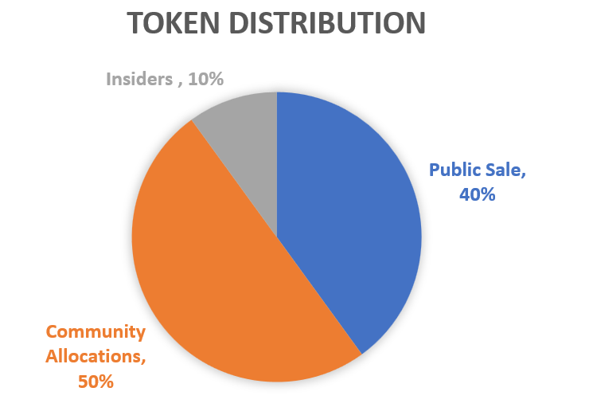

* 40% of the total tokens will be allocated for the public sale because of two reasons: 1. Credit Dao needs enough funding at the starting stage. 2. We hope that both the community and the secondary market will have similar enthusiasm, because we do not want one to be too strong to interfere with the governance structure.
* 10% of the total tokens will be allocated for the insiders (developers). As you can see, the percentage held by insiders (developers) is relatively small compared to the community as a whole. In other words, the status of developers is not solid, and the community can easily elect replacements. This is because we don't want developers to achieve some kind of cartel monopoly in the DPOS consensus mechanism.
* 50% of the total tokens will be allocated for the Community Allocations (developers).
* Besides, Credit DAO has a burn token mechanism for maintain the token distribution. (More details in the Funding Pools part)